**Lab Assignment 4**

This is an android application which has a Login page and an api which converts text to speech.

**Login Page:**

This page contains two text fields to enter username and password, on clicking on sign in button it will check the credentials. Enter the username as admin and password as admin if the credentials are valid then it will direct to the text to speech conversion page.

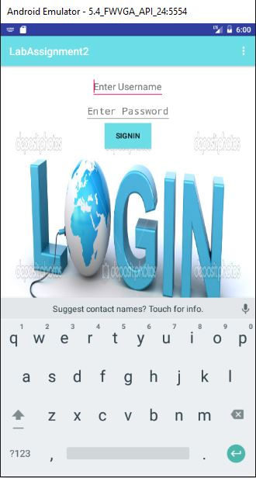

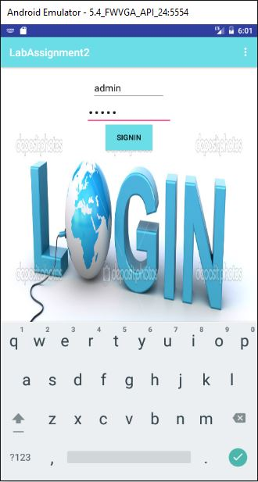

**TexttoSpeechConversion Page:**

This page contains a text filed to enter the text, then this text is taken and converted to speech.





